5/26/2026
Shekhar Podutwar
26/5/2026
AWS Master-Slave Architecture Implementation
Master-Slave architecture

Contents

Document Version History……………………………….…………………………………………….1
Introduction…………………….…………………………………………………………………………….2
Objectives…………………….………………………..….………………………………………………….3
Tools & Technologies Used…………………………………………………………………………….4
Architecture Overview ………………………………………………………………………………….5
Step-by-Step Implementation …………………………………..………………………………….6

Document Version History

Version Number | Date Modified | Author | Changes
Draft | 22/5/2026 | Shekhar | Draft Version

Introduction
This project focuses on implementing Master-Slave architecture on Amazon Web Services to achieve centralized management, synchronization, and high availability of application or database services. The architecture was designed by configuring a Master server to handle primary operations and Slave servers to replicate data or services from the Master node. This setup helps improve scalability, reliability, fault tolerance, and load distribution in cloud environments.
The project involved provisioning and configuring AWS EC2 instances, establishing secure communication between servers, and implementing synchronization or replication mechanisms between Master and Slave nodes.

Objectives

- Implement Master-Slave architecture in AWS Cloud environment.
- Configure centralized management using a Master server.
- Enable synchronization/replication between Master and Slave servers.
- Improve system scalability, reliability, and fault tolerance.
- Reduce downtime and support high availability infrastructure setup.
- Gain hands-on experience in AWS server configuration and distributed architecture deployment.
Tools and Technologies

Category | Tools / Technologies
Cloud Platform | Amazon Web Services (AWS)
Compute Service | Amazon EC2
Operating System | Linux (Ubuntu / Amazon Linux)
Configuration & Access | SSH, PuTTY
Scripting | Bash Shell Scripting
Networking | VPC, Security Groups
Web/Application Server | Apache / Nginx
Monitoring | CloudWatch (Optional)
Version Control | GitHub

Architecture Overview
Client Requests
↓
AWS Load Balancer / Master Server
↓
Master EC2 Instance
(Primary Processing & Management)
↓
Data/Service Replication
↓
Slave EC2 Instances
(Secondary Processing / Backup / Read Operations)
↓
Centralized Infrastructure Management
Step-by-Step Implementation
Step 1: Login AWS and create an instance
- Select AMI (Ubuntu Server 24.04 LTS (HVM), SSD Volume Type)
- Create a Jenkins key pair

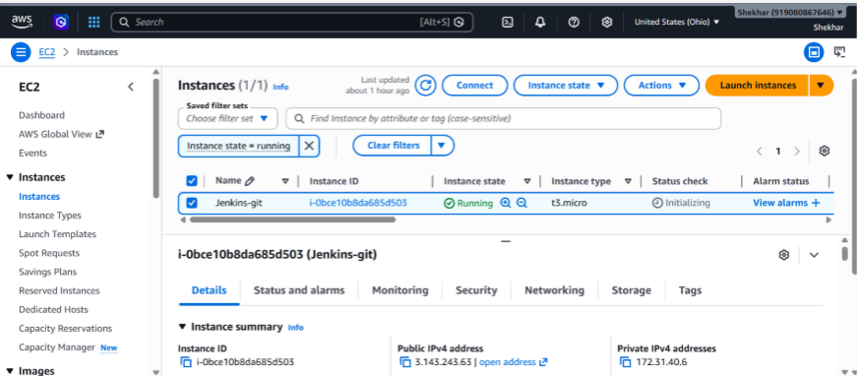

Step 2: Connect putty and run following commands
- ubuntu
- Sudo su -

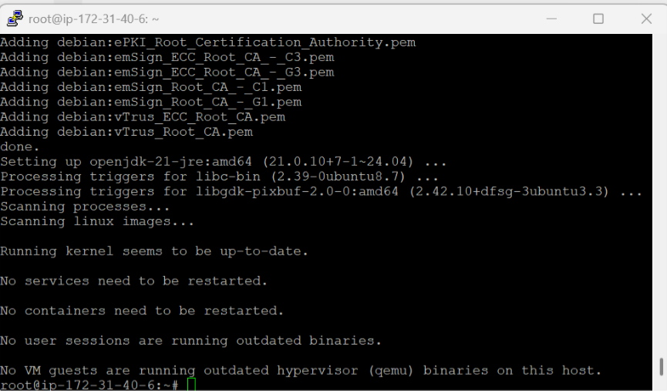
- Update the repository.
(apt update –y)
- Install the Java package.
(apt install fontconfig openjdk-21-jre –y)
- Download the official Jenkins GPG key.
Wget-O/etc/apt/keyrings/jenkins-keyring.asc https://pkg.jenkins.io/debian-stable/jenkins.io-2026.key
- Add the Jenkins repository to the system. echo "deb [signed-by=/etc/apt/keyrings/jenkins-keyring.asc]" https://pkg.jenkins.io/debian-stable binary/ | sudo tee
/etc/apt/sources.list.d/jenkins.list > /dev/null
- Update the repository again.
(apt update –y)
- Install Jenkins.
(apt install jenkins –y)
- Start the Jenkins service.
(systemctl start jenkins)
- Add the Jenkins user to the sudoers file. vim /etc/sudoers
jenkins ALL=(ALL) NOPASSWD: ALL

Step 3: Open port no 8080
- Security --> security group --> edit inbound rule --> add rule
- Must be select Any-where-Ipv4

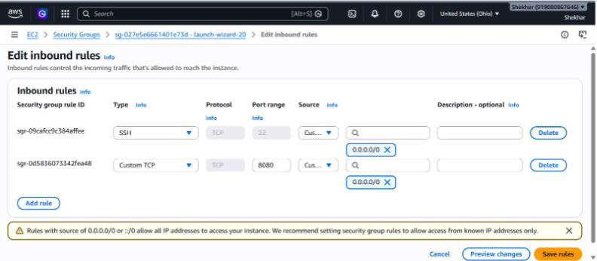
Step 4: To configure Jenkins
- Connect to http:public_ip:8080 from our browser.
- We will be able to access Jenkins through its management interface:
- Default home directory for Jenkins
(/var/lib/jenkins)
- workspace directory of Jenkins. (/var/lib/jenkins/workspace/job1/file1)
- For password
(cat past path)
(cat /var/lib/jenkins/secrets/initialAdminPassword)
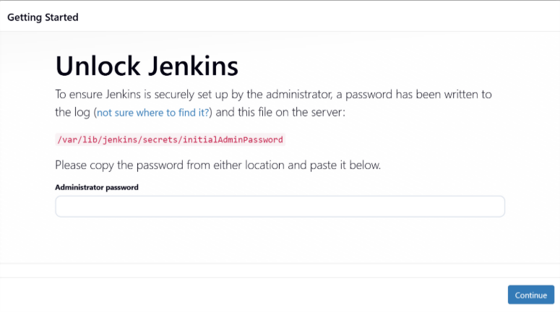
Step 5: Now you can access Jenkins dashboard
- Select installs suggested plugins
- Then set up username and password

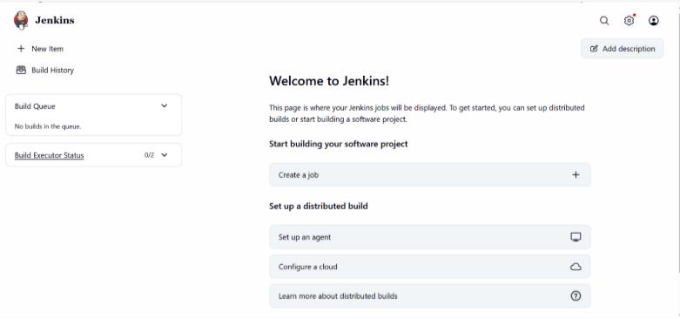
Step 6: Create another server slave and connect putty
- Install java package
- (apt update -y)
- (apt install -y openjdk-17-jdk)
- mkdir /dir1
- cd /dir1
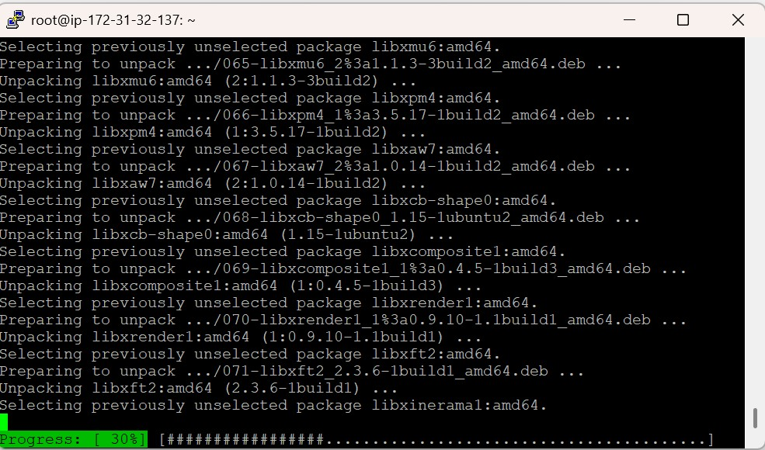
Step 7: Add Node (Agent) in Jenkins
- Go to Manage Jenkins → Manage Nodes and Clouds → Nodes
- Click on New Node
- Enter the Node Name (e.g., slave)
- Select Permanent Agent and click Create
- Configure the following:
  - Remote Root Directory: /dir1
  - Labels: (e.g., slave)
- Keep other settings as default (or configure as needed)
- Click Save

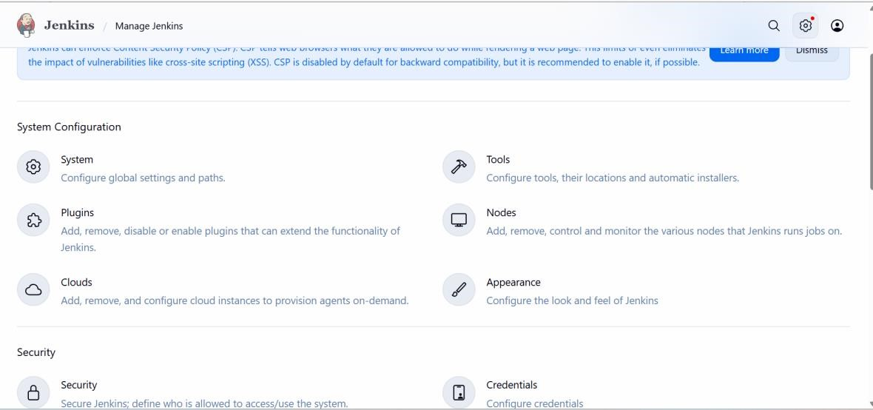

Step 8: Slave server
- Click on project name (slave) add given command on slave server
- curl -sO http://18.219.111.110:8080/jnlpJars/agent.jar
- Run the Agent Using nohup (Background)
- nohup java -jar agent.jar -url http://18.219.111.110:8080/ -secret c07fecce95b5dfd710dc2e1a645329e8770ddcc01312f0f2261971cee3f11401 -name slave -webSocket -workDir "/dir1" &

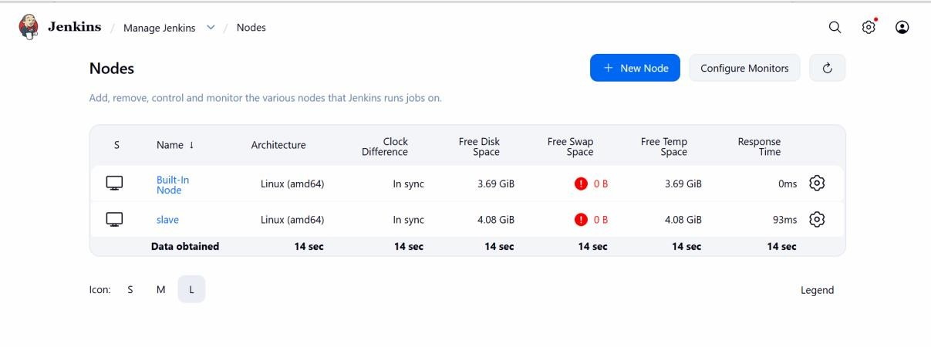
Step 9: Create a job in Jenkins
- Now you can create job in Jenkins
- New item--> job--> freestyle project
- Select Restrict where this project can be run
- Add label (prod)
- Build step --> execute shell --> command (sudo mkdir dir2)
- Apply and save
- Build job

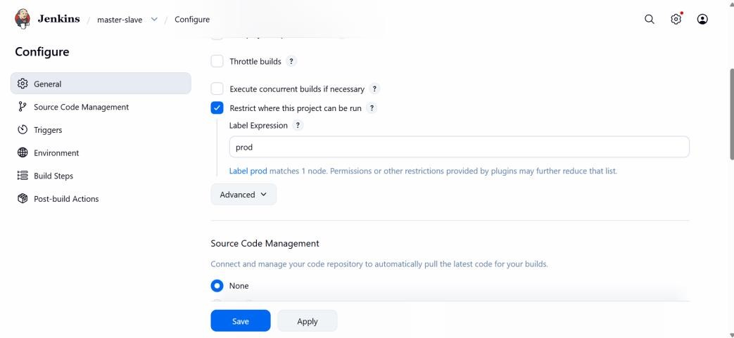

Step 10: default Jenkins directory (slave server)
- Now you can create job in Jenkins
- Default home directory for Jenkins
- (pwd) (ls)
- workspace directory of Jenkins.
- (workspace/project-name)

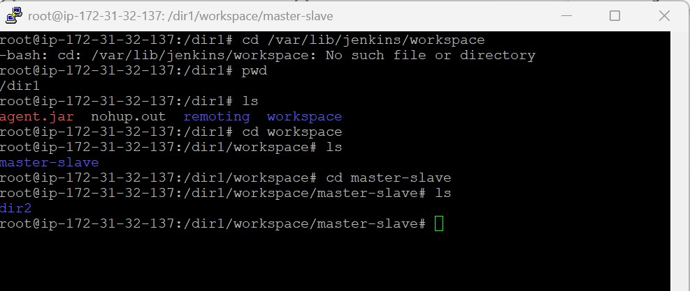

Conclusion
The AWS Master-Slave Architecture project successfully demonstrated the implementation of a scalable and reliable distributed infrastructure using Amazon Web Services. By configuring Master and Slave EC2 instances, the project achieved centralized management, synchronization, and improved availability of services. The architecture reduced the risk of downtime, enhanced system reliability, and provided practical experience in cloud infrastructure deployment, server replication, and AWS networking configuration. This project also strengthened knowledge in distributed system architecture and cloud-based server management.

